City Cycle's Paradise Loop:
This is City Cycle's own version of the Paradise Loop. It is 23 miles of scenic, rolling and...sometimes challenging...terain. ;)
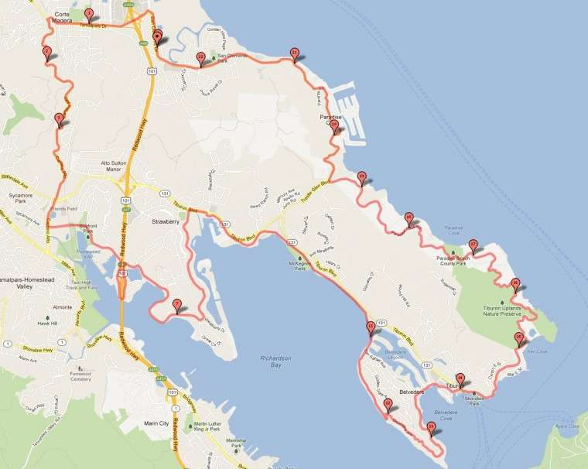
START
-Leave City Cycle heading north on San Clemente...
-Left @ Tamalpais Drive and straight over the Freeway
-In 1 mile turn Left @ Corte Madera Ave (AKA Camino Alto)
-In 2.6 mikes turn Left @ Sycamore (2nd stoplight in Mill Valley)
-At the end of Sycamore stay straight to follow path towards arched wooden foot bridge
-Right @ Hamilton Drive infront of Mill Valley Police Station
-1/2 mile to Right @ Redwood Highway and follow (loops under the freeway)
-Right @ Seminary Drive
-200 meters to Right @ stop sign to stay on Seminary Drive
-Follow for 2.5 Miles (Becomes E. Strawberry Drive)
-Right @ Tiburon Blvd
-200 meters to Right @ Greenwood Cove Drive
-Use Caution at end of drive as you enter Parking Lot @ Blackies Pasture
-Turn Right onto Walking Path
-Follow path for 1.4 miles
-Use Caution at end of path and turn Right at San Rafael Ave
-Take next Right at West Shore Road
-At roads end follow foot path to left and climb The Belveberg
-Go Right at the top onto Belvedere Way
-Make rights at each fork to head towards Tiburon on Beach Rd
-Turn Right @ Main St
-Turn Right @ Tiburon Blvd and follow the main route which becomes Paradise Dr then San Clemente in front of City Cycle
FINISH

The Short Paradise Loop:
Don’t have time for a long ride? Looking for something easy? Here’s a 16 mile ride consisting of scenic & rolling terain...
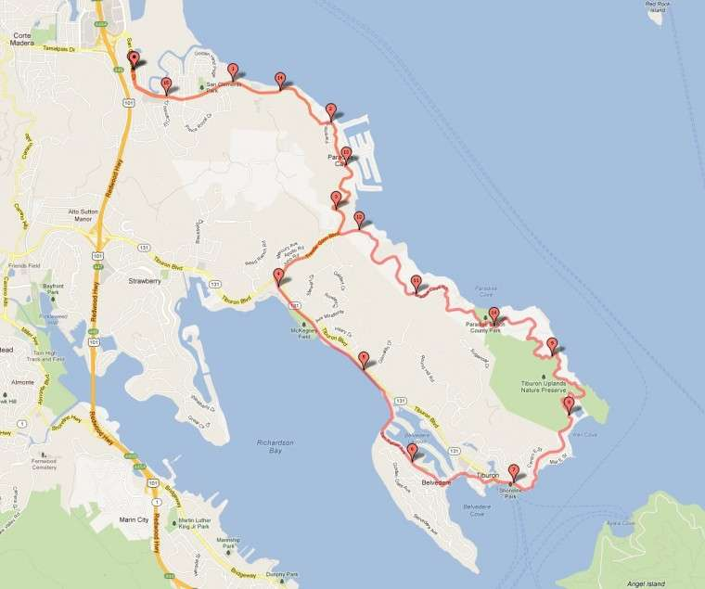
START
-Leave City Cycle heading South(right) on San Clemente...
- In 3.14 miles turn Right at Trestle Glen Rd
-Cross Tiburon Blvd at the stoplight and enter Blackies Pasture
-Find Path heading South along the bay.
-Follow path for 1.4 miles
-Use Caution at end of path and turn Right at San Rafael Ave
-In 1.8 miles turn Left on Beach Rd
-Turn Right @ Main St
-Turn Right @ Tiburon Blvd and follow the main route which becomes Paradise Dr then San Clemente in front of City Cycle
FINISH

